Lesson 9 – Classes

What is a Class?
What is an Object?
What are Attributes and Methods?
Create and use simple class with B4J.
What students should know
3h

Often in programming there is the need to describe similar items in a single way. For example, pupils of a school. Each student is known to have a full name, home address, class to attend, some grades, etc. To monitor and manage this information, a programmer must organize them with systematic way.
Teachers tip
Classes are a tricky subject of programming. Avoid many details and you do not need to go into issues such as inheritance, encapsulation, etc.

Classes
In the previous example with students, we could say that each student has the following information.
Student
1 | Registry Number
2 | Name
3 | Surname
4 | Address
5 | Phone
6 | Email

At the same time, we need functions such as:
- New Student Registration
- Change Student Information
- Student Transfer
- Show Student Information
- Delete Student
Thus, for three students we could have the following elements:
Student 1 |  |  | Student 2 |  |  | Student 3
1 | 125310 |  | 1 | 125311 |  | 1 | 125312
2 | Augusta |  | 2 | Maria |  | 2 | Muḥammad
3 | Ada Byron |  | 3 | Curie |  | 3 | al-Khwarizmi
4 | London |  | 4 | Warszawa |  | 4 | Khwarazm
5 | 37535795 |  | 5 | 678433 |  | 5 | 646456456
6 | ada@lon.uk |  | 6 | maria@wars.pol |  | 6 | algor@khwa.pe

From the above we conclude that essentially for students we have similar data and similar actions that we can apply to them. Grouping all student data and functions into an independent and single code is called class. Every student Called Object or Instance of the class. Also, the variables that characterize the student surname, Registry number etc. Called Properties and the functions Described Methods.
Remember
We call class the grouping of data and functions into a single and independent code.
Object or Instance of the class are all independent elements that result from the use of the class.
Variables for an object are called properties.
The functions applied to an object are called methods.

Some of the advantages of using classes are flexibility in the use of code, speed and ease in developing programs and reusing code in other programs.

Example of class in B4J
A library has a set of books which it lends to readers who subscribed in the library. Each book has features such as title, author, publisher, year of publication. Also, the Insert Book, Show Book Items, Change Book Items functions apply to each book.
Create an application in B4J that implements the Book class with the properties and methods mentioned above.

Implementation methodology
- Create a new application B4XPages and give the name “library”.
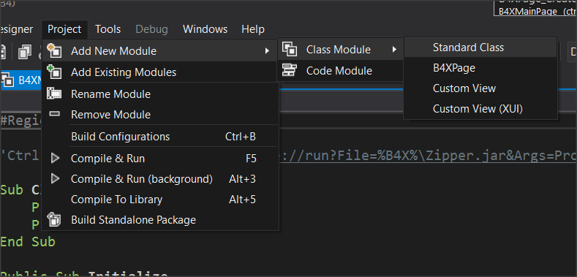
- From menu Project – Add New Module – Class Module menu select Standard Class.
- In the dialog box, name clsBook (i.e. class Book)
- A new code tab named clsBook will be created.
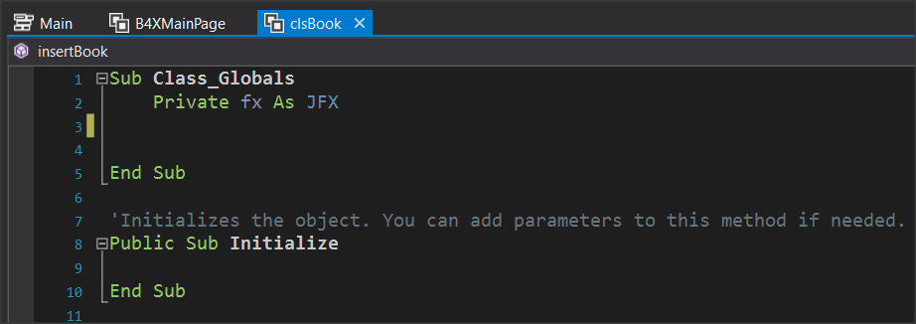
- Within the Class_Globals routine, add all the variables that will be the properties of the class.
  - Book Title
  - Author Name
  - Publisher
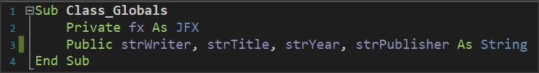
  - Release Date

- Finally, you must implement the subprograms that will implement the methods:
  - Insert a book,
  - Show Book Items,
  - Change Book Items
Teachers tip
Be careful to explain that all the variables and methods you create are public so that objects can use them.

Insert a book.
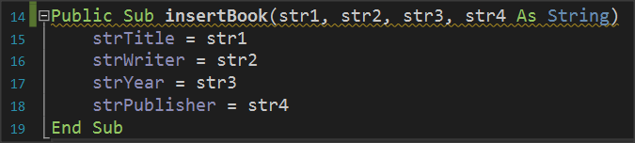
This is a subprogram that accepts 4 string data as parameters and then assigns it in the order that it is inserted into the subprogram into the variables strTitle, strWiter, strYear, strPublisher.

Show Book Items.
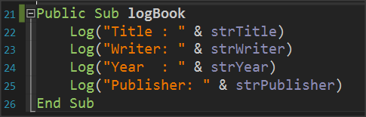
The subprogram displays with log command the properties of the Books class or in other words the variables that describe the class.

Change book items.
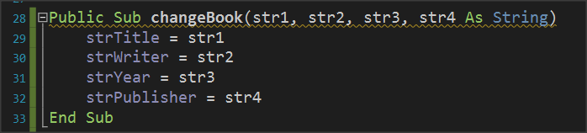
The method of changing items accepts as parameters new elements for the class and changes the property values of the corresponding properties.

The Initialize subprogram.
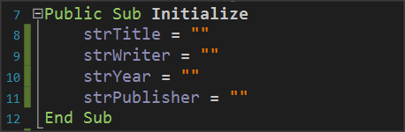
The Initialize routine is used to give initial values to variables or do any other functions required when creating an object from a class.

Use Class
Back on tab B4XMainPage it's time to use the clsBook class.
- First create clsBook objects.
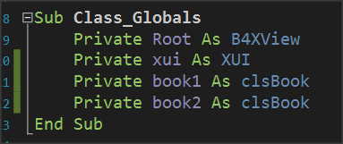
where book1, book2 are two clsBook objects with all the properties and methods discussed previously.

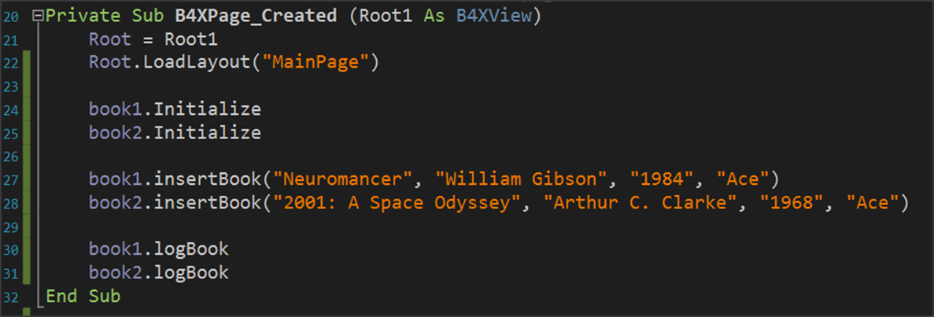
Use of methods
The first method to be used in objects is the initialize method.
Remember
Initialize is not optional method. It’s the first method you must use before do anything with an object

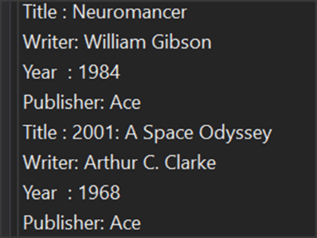
The InsertBook method then enters values for the two books in the object properties.
End the logbook method displays the contents of the properties of each book.
Remember
Each property can be called by writing the object name, then a period and the method name. Some methods need parameters to work while others don't.
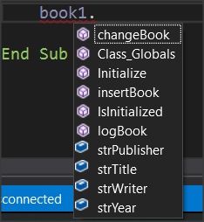
Each time you write an object name and pressing the period B4X displays a window with all available properties and methods of the class. The IsInitialized method checks whether the object is initialized and exists in all classes that you create.

Getters and Setters
Most of the time the properties of an object are kept private in order to avoid changes beyond what is allowed. This process is called encapsulation. To allow the use of private properties, the language uses public processes called get and set followed by the property name.
In the example of books, additional methods will be created as follows:

Sub Class_Globals
Private fx As JFX
Public strWriter, strTitle, strYear, strPublisher As String
Private strWriter, strTitle, strYear, strPublisher As String
End Sub

Public Sub getWriter() As String
Return strWriter
End Sub

Public Sub setWriter(w As String)
strWriter = w
End Sub

Public Sub getTitle() As String
Return strTitle
End Sub

Public Sub setTitle(t As String)
strTitle = t
End Sub

Public Sub getYear() As String
Return strYear
End Sub

Public Sub setYear(y As String)
strYear = y
End Sub

Public Sub getPublisher() As String
Return strPublisher
End Sub

Public Sub setPublisher(p As String)
strPublisher = p
End Sub

Also, to insert a book using the insert method can be done:
Public Sub insertBook(str1, str2, str3, str4 As String)
setTitle(str1)
setWriter(str2)
setYear(str3)
setPublisher(str4)
End Sub

The previous change to the insertBook method does not exclude its use and by directly assigning the properties of the classes as previously presented. Using set methods, you can integrate additional controls into the data you are about to enter.
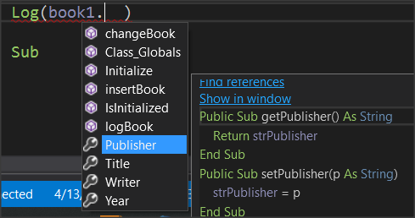
Finally, when you want to use the get and set do it by writing the name that follows the get and set.

For example, to set another value to the author of book1 you can simply write:
book1.Writer = "Wil. Gibson"

Log(book1.Writer)

Exercises
- In the first example of the course, implement in B4J the Student class with properties:
- Registry Number
- Name
- Surname
- Class
- Phone
- Email
and methods
- New Student
- Show Student
- Change Class
- Change Phone

- If only one teacher teaches a specific course in a school implement the Course class with properties
  - Lesson
  - Class
  - Hours
  - Professor
and methods
- New Lesson
- Change Hours
- Change Professor
- Show Lesson

- A store has computers for sale. For each computer are recorded:
  - The type (desktop, laptop),
  - the model,
  - its price,
  - Its cpu (I3, i5, i7, i9)
Create a class that implements a computer with the above properties and methods that you will create. Be careful to check that the values entered in the type and cpu are those in the parenthesis.

